

SMART DOOR LOCK USING ARDUINO UNO AND PIR SENSOR

ELECTRONIC DEVICES AND CIRCUITS PROJECT

SUBMITTED BY :

HAMAND SREKAND CHANDRASEKARAN
24BEI0109
hamand.sre2024@vitstudent.ac.in
Mobile No: 8667690910

Name of the Faculty: Dr. ARUNKUMAR G
Name of Department: Department of Energy and Power Electronics
School / Centre Name: School of Electrical Engineering

ACADEMIC YEAR: 2025
Contents

Sl.No | Content
1 | Motivation
2 | Literature Survey
3 | Objectives
4 | Project Block Diagram
5 | Processor specifications
6 | Processor Pinouts
7 | Processor applications
8 | Limits and Advantages
9 | Circuit Diagram
10 | Circuit Operation and Coding
11 | Stage-wise results
12 | Photograph of work
13 | Validation with the design table
14 | Datasheet
15 | Project Components
16 | Conclusion of the project
17 | Online Links

Project Video:

video_20251028_124939_edit.mp4

1 Motivation
In today’s world, security has become a major concern for both homes and workplaces. Traditional lock-and-key mechanisms are often unreliable and can be easily tampered with or misplaced. This motivated the development of a Smart Door Lock System that provides a more secure, convenient, and automated solution.
By integrating motion detection with password-based access control, the system ensures that only authorized individuals can enter, while also alerting the user to any unauthorized access attempts. The use of Arduino makes the project affordable, programmable, and suitable for students and hobbyists to understand real-world applications of embedded systems in home automation and security.

2 Literature Survey
In recent years, the demand for smart and secure door locking systems has increased due to rising safety concerns in homes and offices. Many researchers have developed different types of electronic locks using technologies such as RFID cards, fingerprint sensors, Bluetooth modules, and keypad-based password systems. Among these, Arduino-based keypad locks are widely used because they are low-cost, easy to program, and reliable for small-scale applications.
Existing projects generally use a 4x4 matrix keypad for password entry, a servo or solenoid motor for locking mechanisms, and an LCD to show system status. While these systems work effectively, most of them operate continuously and do not include motion sensing or proactive activation. Some designs also lack real-time alerts that notify or warn users during unauthorized access attempts.
To overcome these limitations, the present work proposes an improved Arduino-based Smart Door Lock System that combines PIR motion detection, password authentication, and visual and audible alerts using LEDs and a buzzer. This integration makes the system more intuitive and precise control of hardware actions. Moreover, the inclusion of the PIR sensor adds a layer of automation by detecting user presence, making the system energy-efficient and interactive.
Overall, this project demonstrates how embedded systems and automation can be combined to create a low-cost, intelligent, and secure access control system. It serves as a practical example of how microcontroller-based designs can be applied to real-world problems, emphasizing the importance of electronic design, programming, and system integration in modern security applications. eractive, power-efficient, and secure.

3 Objectives

The main objective of this project is to design and implement a Smart Door Lock System using an Arduino Uno microcontroller to enhance security and convenience through electronic access control. The system seeks to overcome the limitations of traditional mechanical locks by introducing password-based authentication and automated door operation. The project focuses on developing a password-protected door locking mechanism using a 4×4 keypad interface, where the user can input a secure access code. An LCD module is incorporated to provide real-time user interaction and display the system status, such as password entry and access confirmation. A servo motor is employed to automatically control the locking and unlocking of the door based on the correctness of the entered password. In addition, LED indicators and a buzzer offer visual and audible feedback to signify access approval or denial. To further enhance functionality, a PIR sensor is integrated to detect motion and activate the system when a user approaches. Overall, this project aims to create a low-cost, reliable, and user-friendly smart security system suitable for homes, offices, and laboratories, demonstrating the effective integration of embedded systems, sensors, and automation for secure access control.
4 Project Block Diagram
Power Supply



Arduino Uno (Main)

PIR Sensor | Keypad 4x4 | LCD (I2C) | Buzzer & LEDs

5 Processor specification

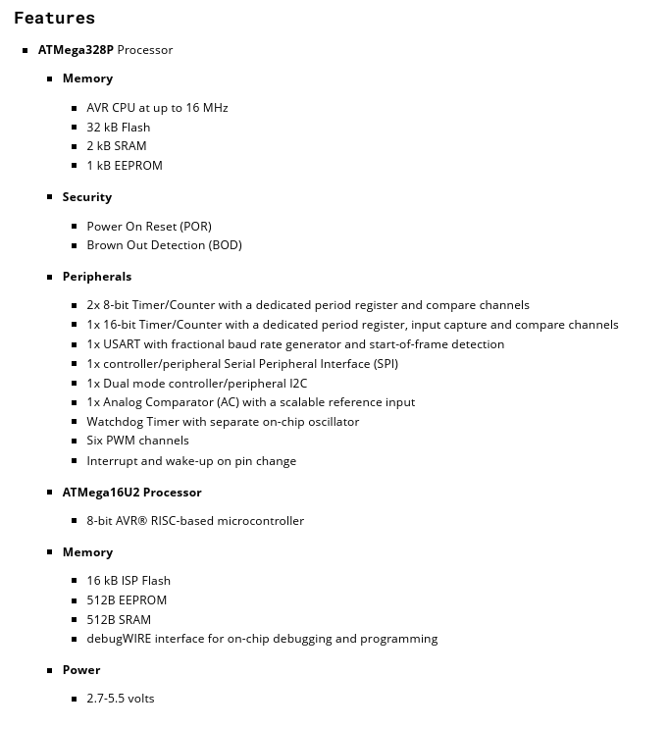

6 Processor Pinouts

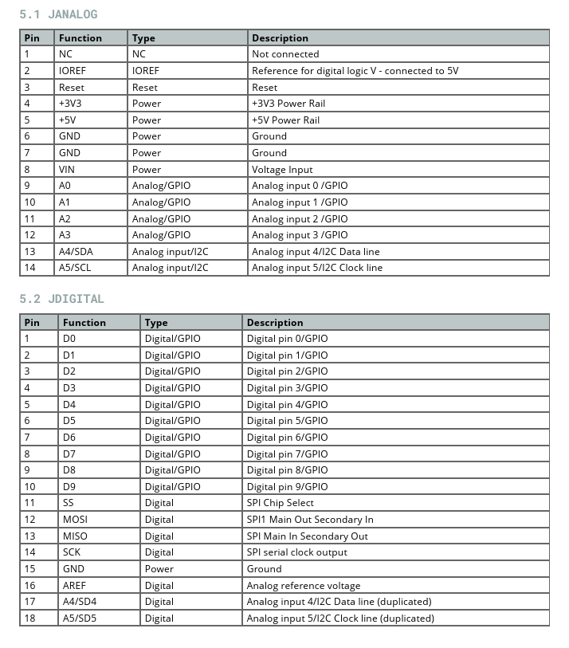

7 Processor Applications

The ATmega328P microcontroller (used in the Arduino Uno) is widely used in embedded systems and IoT-based automation due to its low cost, simplicity, and reliability. Its applications include: Home Automation Systems – controlling lights, doors, and appliances. Security Systems – implementing smart locks, motion detectors, and alarm systems. Industrial Automation – monitoring sensors, motors, and process control systems. Robotics – controlling motors, sensors, and servo mechanisms in small robots. IoT Prototyping – used in networked devices for data collection and control. Educational Projects – ideal for learning microcontroller programming and embedded design. Medical Devices (Basic Level) – monitoring parameters like temperature or pulse rate. Consumer Electronics – used in electronic gadgets, timers, and remote control units. In this project, the ATmega328P acts as the main processing unit, reading sensor inputs (PIR, keypad), verifying passwords, and controlling outputs like the servo motor, LEDs, and buzzer — demonstrating its use in a real-time embedded security application.

8 Limits and Advantages
Limitations:
One of the major limitations of the system is its restricted authentication mechanism, as it relies solely on a fixed password without any encryption or multi-factor authentication, making it susceptible to password guessing or observation. The absence of remote access or IoT integration means that the system cannot be monitored or controlled via smartphone or the internet, limiting its functionality to local operation. Another drawback is its dependence on continuous power supply — the system ceases to operate during power failures unless supported by a backup battery. The PIR sensor used for motion detection also has a limited range and sensitivity, making it ineffective for long-distance or multi-angle detection. Additionally, the password entry process on a keypad may expose the password if entered in a public or shared environment. From a mechanical perspective, the servo motor is suitable only for small or lightweight door mechanisms and cannot handle heavy-duty locks. Furthermore, the system does not store user data or maintain access logs, which restricts its application in professional or large-scale security environments. Minor design limitations also include the lack of tamper detection and the absence of real-time alerts in case of repeated unauthorized attempts.
Advantages:
Despite these constraints, the Smart Door Lock System provides several significant advantages. It ensures enhanced security by combining motion detection with password-protected access, preventing unauthorized entry. The system is cost-effective, as it utilizes affordable and easily available components such as the Arduino Uno, PIR sensor, and 4×4 keypad, making it suitable for educational and prototype-level implementations. It offers user-friendly operation, with the LCD providing clear instructions and real-time feedback during password entry. The system exhibits a high level of automation, as the PIR sensor activates the device automatically upon detecting movement, reducing the need for manual switches. Moreover, visual and audible indicators like LEDs and a buzzer deliver immediate feedback on access status, ensuring better user awareness. The design is also energy efficient, since it remains in an idle state until motion is detected, thereby minimizing power consumption. It is customizable, allowing users to easily modify the password or expand the system by adding IoT modules, fingerprint sensors, or GSM communication for advanced features. The project further holds strong educational value, offering practical exposure to sensor interfacing, embedded programming, and automation concepts. Overall, the Smart Door Lock System represents an efficient, scalable, and accessible solution for enhancing everyday security using modern embedded technologies.

9 Circuit Diagram

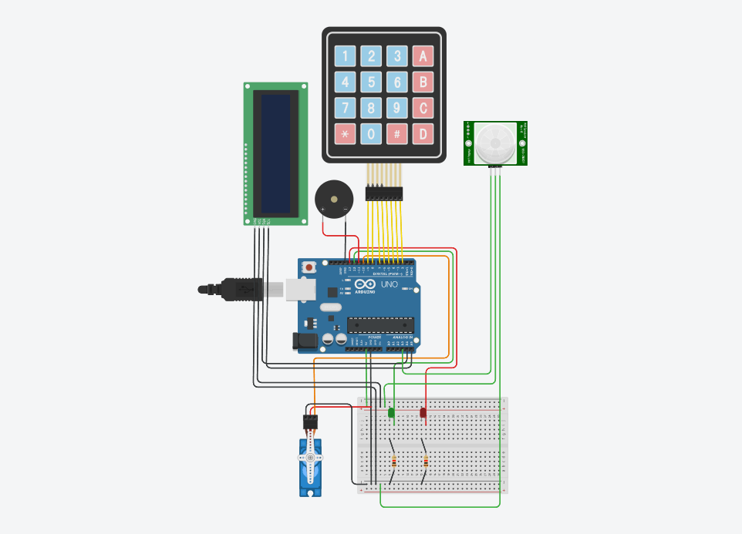
Figure 1: Circuit Diagram of Smart Door Lock System

Circuit Analysis
The circuit of the Smart Door Lock System is designed around the Arduino Uno (ATmega328P) microcontroller, which serves as the central control unit. The PIR sensor (HC-SR501) continuously monitors for motion near the door and outputs a digital HIGH signal to the Arduino input pin A3 whenever motion is detected. Upon receiving this signal, the Arduino activates the system and prompts the user to enter a password. The 4×4 matrix keypad, connected to pins D2–D9, allows the user to input the password, which is processed and verified by the Arduino in real time. The I²C 16×2 LCD display, connected via pins A4 (SDA) and A5 (SCL), provides visual feedback to the user by displaying system messages such as password entry, access granted, or denied.
The servo motor, connected to pin D10 (PWM), controls the physical locking mechanism of the door. It rotates to unlock when the correct password is entered and returns to the locked position after a short delay. The buzzer, connected to D11, produces an audible alert to indicate an incorrect password or intrusion attempt, while the green LED (D12) and red LED (D13) provide visual indications of access status. The entire circuit is powered by a 5V regulated power supply, which energizes both the Arduino and its connected peripherals. However, since the servo motor can draw higher current during movement, it is recommended to use a separate, regulated 5V supply to ensure stable operation and prevent voltage drops. The system’s overall circuit is compact, efficient, and capable of integrating multiple sensors and actuators to achieve reliable electronic access control.

Working Flow

When a person approaches the door, the PIR sensor detects motion and sends a digital HIGH signal to the Arduino, activating the system. The LCD display then prompts the user to enter a password using the 4×4 keypad. The Arduino compares the entered password with the stored one; if the input matches, it sends a PWM signal to the servo motor, causing it to rotate and unlock the door. Simultaneously, the green LED glows, and the buzzer emits a short tone to confirm successful access. If an incorrect password is entered, the red LED turns on, and the buzzer sounds a longer warning beep, indicating denied access. After a short delay, the servo returns to its locked position, and the system resets for the next operation. This sequential flow ensures both security and automation, allowing the system to operate efficiently with minimal user intervention.

10 Components Used

Sl. No. | Component | Control Pin | Arduino Pin Connection | Function
1 | PIR Sensor (HC-SR501) | OUT | A3 | Detects motion and sends a digital signal
2 | 4x4 Keypad | Row 1–4 | D2, D3, D4, D5 | Rows for keypad scanning
 |  | Column 1–4 | D6, D7, D8, D9 | Columns for key detection
3 | Servo Motor (SG90) | Signal | D10 | Controls door lock movement
4 | LCD Display (I2C 16x2) | SDA | A4 | I2C data line
 |  | SCL | A5 | I2C clock line
5 | Buzzer (Active 5V) | Signal | D11 | Sounds an alarm during motion detection
6 | Green LED | Anode | D12 | Indicates correct password
7 | Red LED | Anode | D13 | Indicates wrong password or motion detection

Working Principle

Stage 1: Motion Detection and System Activation
In the initial stage, the PIR sensor continuously monitors for human motion near the door. When motion is detected, the sensor sends a signal to the Arduino Uno, which activates the system. The LCD turns on and prompts the user to enter a password, while the red LED and buzzer indicate that the system is now active and monitoring for input.

Stage 2: Password Entry through Keypad
In this stage, the user enters a password using the 4×4 matrix keypad. Each key pressed is displayed on the LCD screen and read by the Arduino. The entered digits are compared in real-time with the predefined password stored in the Arduino’s memory. This provides an interactive and responsive interface for the user.

Stage 3: Password Verification and Decision Making
Once the user presses the “#” key, the Arduino compares the entered password with the stored one. If the password matches, the Arduino interprets this as authorized access and unlocks the door. If the password is incorrect, it is treated as an unauthorized attempt, and a warning response is triggered.

Stage 4: Door Control and Alert System
For correct passwords, the servo motor rotates to unlock the door, and the green LED lights up, indicating successful access. After a short delay, the servo automatically returns to the locked position.
If the password is incorrect, the buzzer sounds along with the red LED, and the LCDs “Access Denied.” This provides both visual and audible alerts to enhance security.

11 Arduino Code

#include <Keypad.h>
#include <Servo.h>
#include <Wire.h>
#include <LiquidCrystal_I2C.h>

// LCD setup
LiquidCrystal_I2C lcd(0x27, 16, 2);

// Servo setup
Servo lockServo;
int servoPin = 10;

// LED and Buzzer
int ledGreen = 12;
int ledRed = 13;
int buzzer = 11;

// PIR sensor
int pirPin = A3;

// Keypad setup
const byte ROWS = 4;
const byte COLS = 4;
char keys[ROWS][COLS] = {
{'1', '2','3','A'},
{'4','5','6','B'},
{'7','8','9','C'},
{'*','0','#','D'}
};
byte rowPins[ROWS] = {2, 3, 4, 5};
byte colPins[COLS] = {6, 7, 8, 9};
Keypad keypad = Keypad(makeKeymap(keys), rowPins, colPins, ROWS, COLS);

// Password setup
String password = "1234";
String input = "";

void setup() {
Serial.begin(9600);
lcd.init();
lcd.backlight();
lcd.print("Smart Door Lock");
delay(1500);
lcd.clear();
lcd.print("Enter Password:");
lockServo.attach(servoPin);
lockServo.write(0); // locked position
pinMode(ledGreen, OUTPUT);
pinMode(ledRed, OUTPUT);
pinMode(buzzer, OUTPUT);
pinMode(pirPin, INPUT);
Serial.println("System Ready...");
Serial.println("Use '#' to submit, '*' to clear input.");
}

void loop() {
// PIR motion detection
int motion = digitalRead(pirPin);
if (motion == HIGH) {
digitalWrite(ledRed, HIGH);
tone(buzzer, 1000); // Continuous alert tone
}
else {
digitalWrite(ledRed, LOW);
noTone(buzzer);
}

// Keypad input for password
char key = keypad.getKey();
if (key) {
Serial.print("Key Pressed: ");
Serial.println(key);

if (key == '#') {
Serial.print("Submitted Password: ");
Serial.println(input);
if (input == password) {
unlockDoor();
}
else {
wrongPassword();
}
input = "";
}

else if (key == '*') {
input = "";
lcd.setCursor(0, 1);
lcd.print(" "); // clear line
Serial.println("Input Cleared");
}

else {
input += key;
lcd.setCursor(0, 1);
lcd.print(input);
Serial.print("Current Input: ");
Serial.println(input);
}
}

delay(100);
}

void unlockDoor() {
lcd.clear();
lcd.print("Access Granted");
digitalWrite(ledGreen, HIGH);
lockServo.write(90);
delay(3000);
lockServo.write(0);
digitalWrite(ledGreen, LOW);
lcd.clear();
lcd.print("Enter Password:");
Serial.println("Access Granted!");
}

void wrongPassword() {
lcd.clear();
lcd.print("Access Denied!");
digitalWrite(ledRed, HIGH);
tone(buzzer, 1000, 500);
delay(1000);
digitalWrite(ledRed, LOW);
noTone(buzzer);
lcd.clear();
lcd.print("Enter Password:");
Serial.println("Access Denied!");
}

12 Photograph of Work

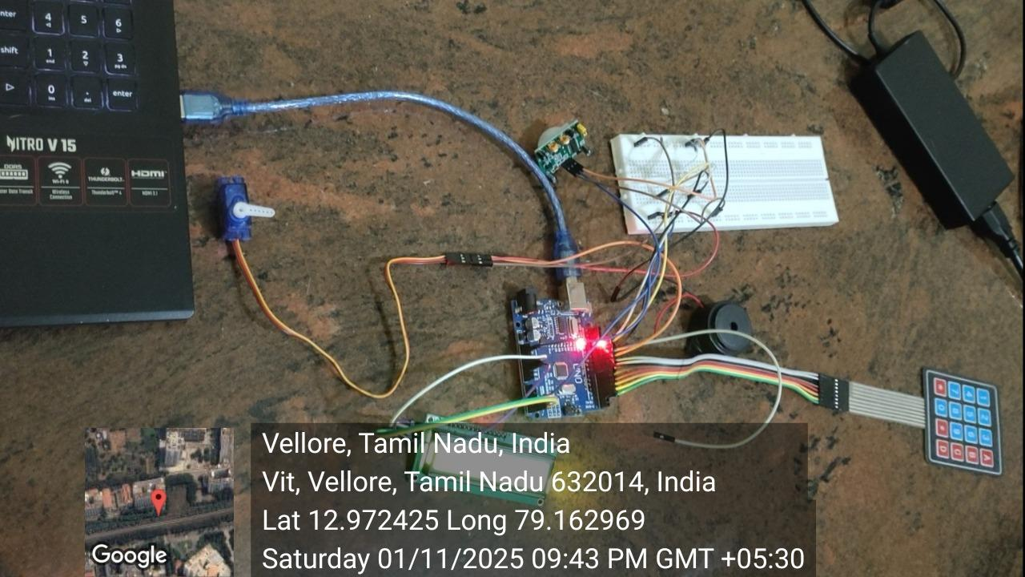

13 Validation with Design Table

Sl. No. | Test/Function | Input Condition | Expected Output | Observed Output | Status
1 | PIR Sensor Activation | Human motion near the sensor | System activates; buzzer & red LED turn ON | Works as expected | Pass
2 | No Motion Detected | No movement | System remains idle | Works as expected | Pass
3 | Password Entry | Correct password entered (“1234”) | Servo unlocks door; green LED turns ON; “Access Granted” on LCD | Works as expected | Pass
4 | Password Entry | Incorrect password entered | Buzzer sounds; red LED ON; “Access Denied” on LCD | Works as expected | Pass
5 | Servo Motor Operation | After the correct password | Servo rotates 90° then returns to 0° after delay | Works as expected | Pass
6 | LCD Display | During all operations | Displays status messages clearly | Works as expected | Pass
7 | System Reset | After unlocking | System returns to “Enter Password” state | Works as expected | Pass

14 Datasheet

Arduino Uno
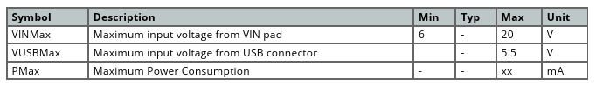

PIR Sensor

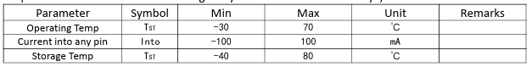
LCD
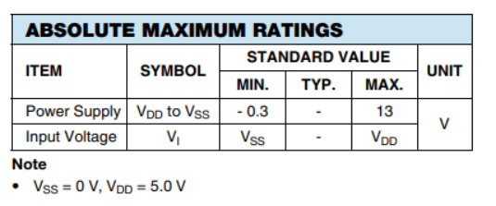

15 Project Component

S.No | Component Name | Description / Use | Purchase Link
1 | Arduino UNO R3 | Main microcontroller board for controlling the project | Amazon.in
2 | HC-SR501 PIR Sensor | Detects human motion for automation/security | Probots.in
3 | 4×4 Matrix Keypad | Used for password or code input | Robu.in
4 | SG90 Mini Servo Motor | Controls lock movement or small actuators | ComponentsTree.com
5 | 16×2 LCD (I2C Interface) | Displays system messages and user prompts | Robu.in
6 | Active Buzzer Module | Sounds an alarm or alert on wrong inputs | ElectronicSpices.com
7 | Jumper Wires (M–M, M–F) | For circuit connections on the breadboard | Amazon.in
8 | Breadboard (830 Points) | For temporary circuit connections | Robu.in
9 | USB Cable (Type-B) | For Arduino programming and power | Amazon.in
10 | Power Supply (9V Battery / Adapter) | Powers the circuit | Robocraze.com

16 Results and Discussion

The Smart Door Lock System was successfully developed and tested using an Arduino Uno, keypad, LCD display, PIR sensor, servo motor, LEDs, and buzzer. The system performed effectively, detecting motion through the PIR sensor and prompting the user to enter a password on the keypad.
When the correct password was entered, the servo motor unlocked the door, and the green LED indicated authorized access. In contrast, entering an incorrect password activated the red LED and buzzer, signaling unauthorized access. The LCD and Serial Monitor accurately showed the password entry process and system status in real time.
The project achieved its goal of creating a secure, reliable, and low-cost smart locking system, demonstrating how microcontroller-based automation can enhance everyday security applications.

Conclusion

The system reliably detects motion, processes password input, and provides immediate visual and audio feedback for authorized and unauthorized access. This project showcases the practical application of microcontroller-based control and can be further enhanced by incorporating features such as biometric authentication or remote monitoring. In summary, the project successfully achieves its goal of creating a low-cost, efficient, and secure electronic door locking system suitable for real-world applications.

17 References

https://circuitdigest.com/microcontroller-projects/digital-keypad-security-door-lock-using-arduino?utm_source=chatgpt.com

https://projecthub.arduino.cc/jayesh_nawani/door-lock-system-with-arduino-54d18a

https://roboelectrixx.com/arduino-based-door-lock-system-with-password/
[Complete Tutorial] IoT Door Lock Project Using Arduino - Complete circuit and code

18 Appendix

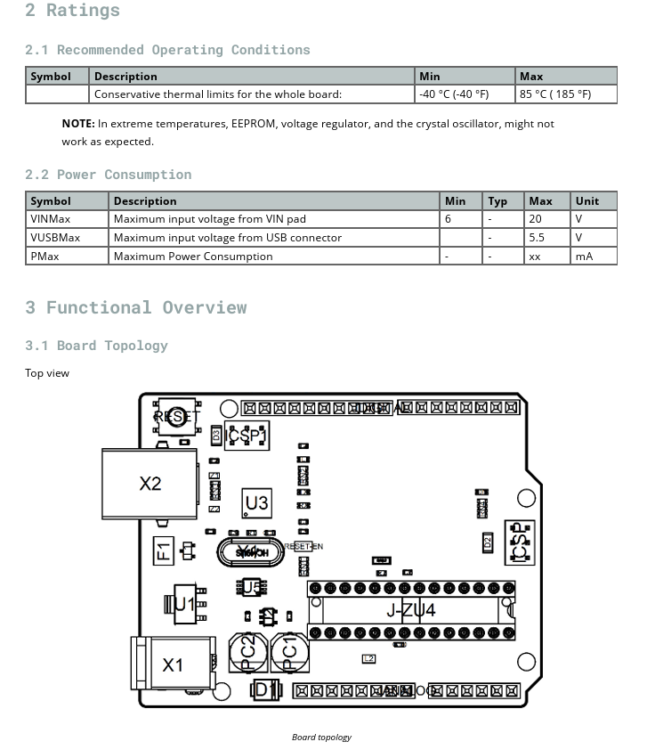
Arduino UNO:
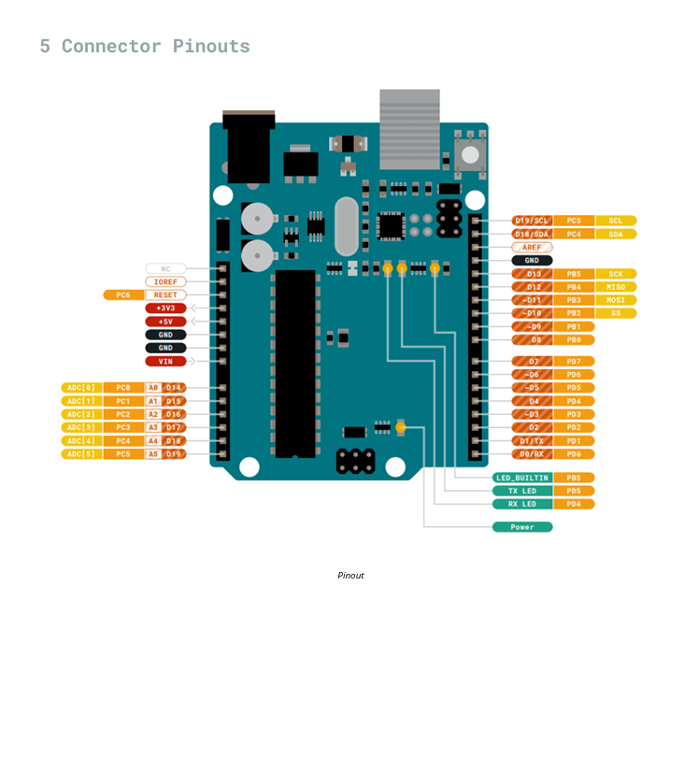

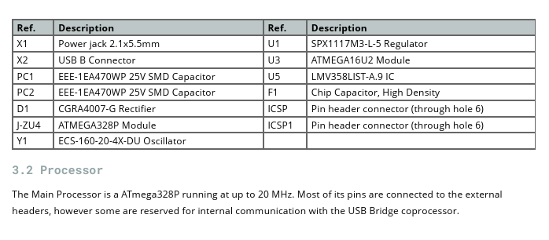

PIR sensor:

